Sending Event Viewer Logs to Cloud watch 20/09/2022

Reference Link

<https://aws.amazon.com/premiumsupport/knowledge-center/cloudwatch-upload-windows-logs/>

1.Attach policy to the instance

cloudwatchAgentServerPolicy

AmazonEc2RoleForSSm

Ssmfullaccess

2.Go to Systems Manager and to Run Command

3. In run command

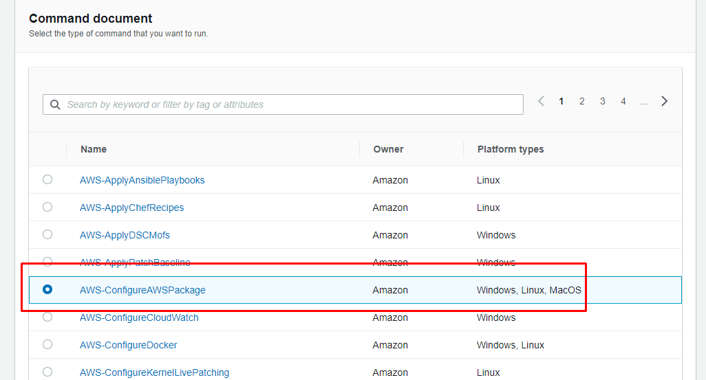

4.give name and version=latest

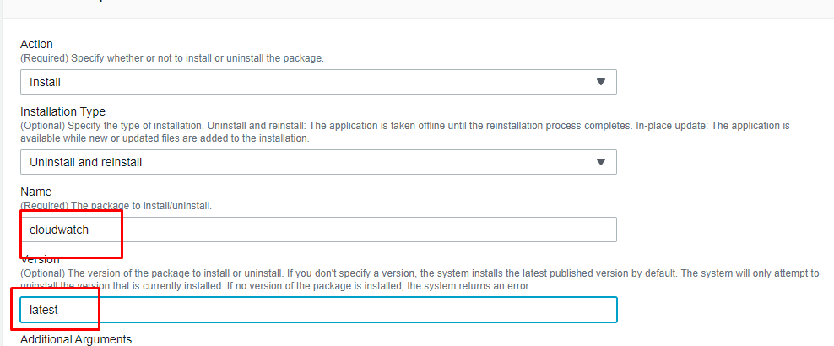

5.choose the instance and Run

6.Go inside the server and open cmd

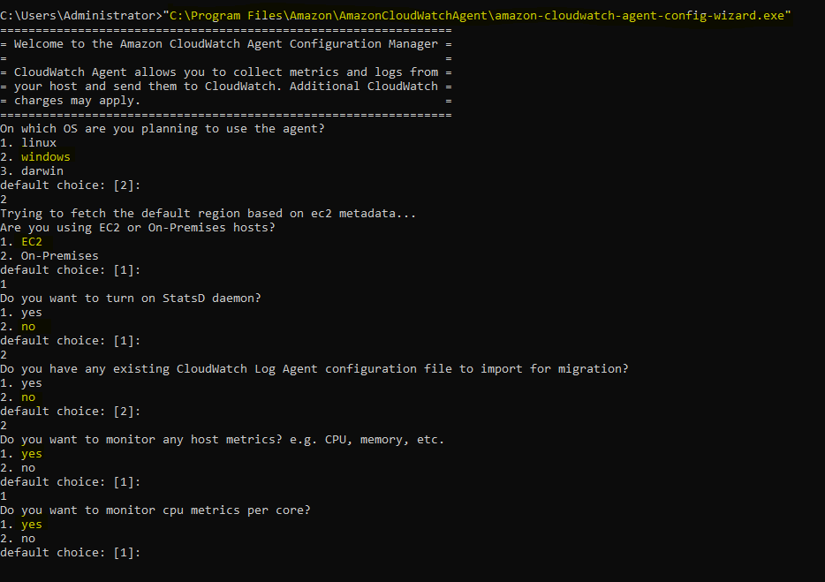

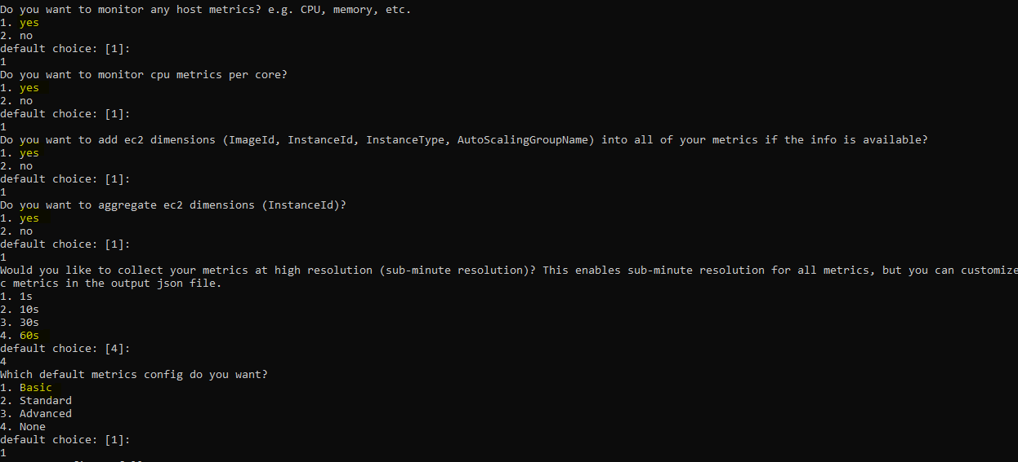

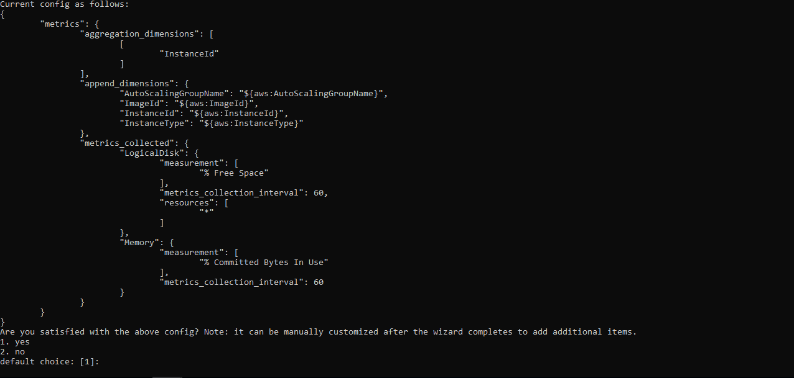

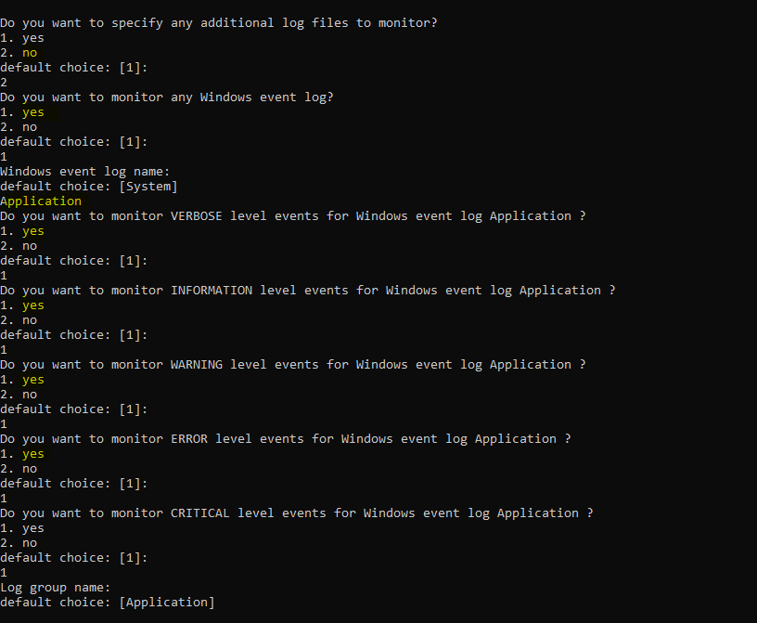

In the Above Screenshot windows event log name specify custom name like application,security,setup

By default it will take system

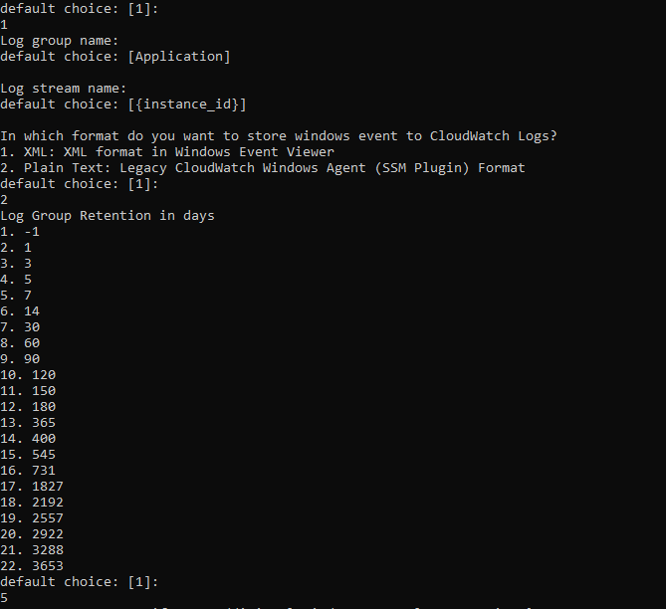

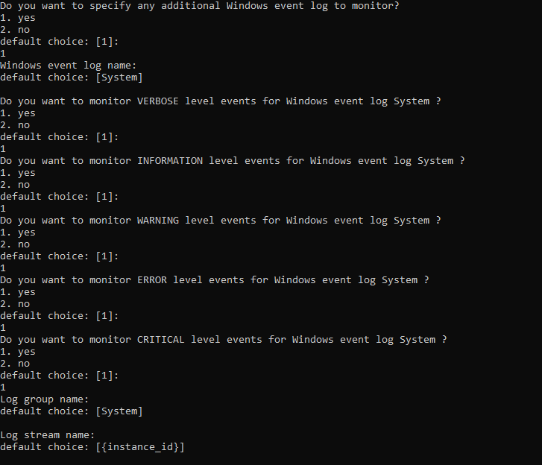

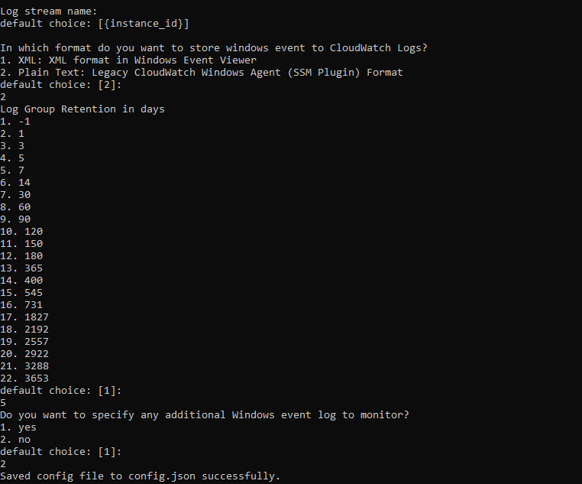

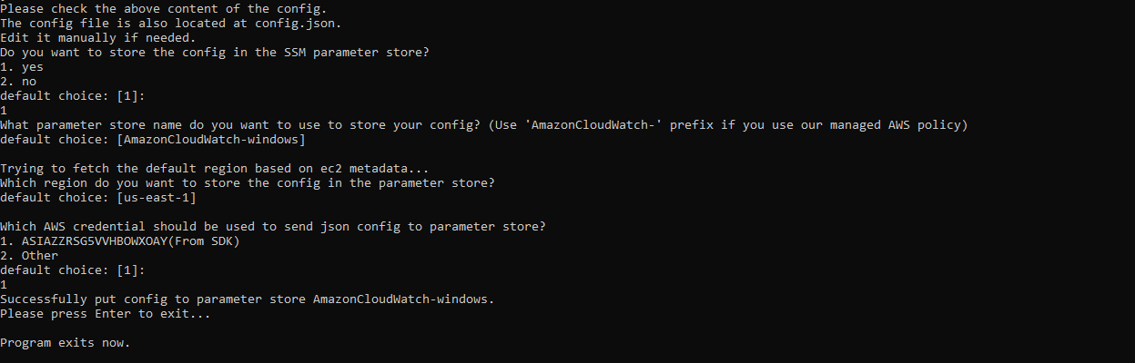

Go To run command in systems manager

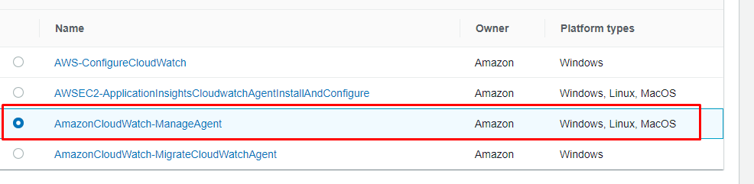

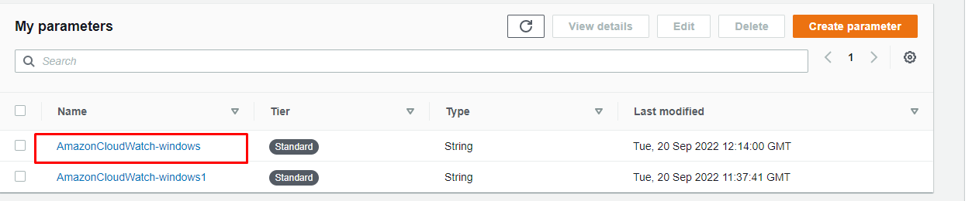

In optional Configuration Location provide the name of parameter

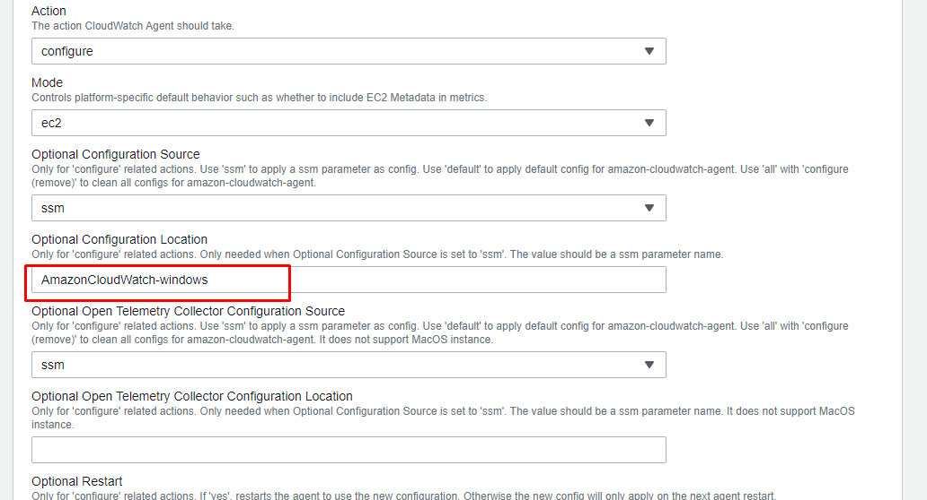

Select the instance and run